DILLIP KUMAR NAYAK
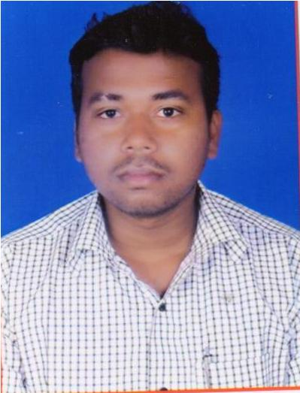 | Address for Communication:  Qtr no.B/195 Sector-19  Rourkela-5 Sundargarh  Odisha Pin: 769005  Mobile No: 9777560632  E-mail: dillip5836@gmail.com

Career Objective

I want to work in an organization where I can play a crucial role in the development process and also want to enhance my ability and take the company to different height where I can be also a part of the growth and appreciated for my work.

Experience
JAY IRON & STEEL PVT LTD ROURKELA: (1 year)
Job Responsibilities
JUNIOR FITTER MECHANICAL MAINTENCE DEPARTMENT
- Jaw crusher
- Iron circuit
- Coal circuit
- Bag filter

MAHAVIR FERRO PVT LTD ROURKELA: (6 months)
Job Responsibilities
BOILER FIELD OPERTOR SYSTEM (AFBC) 12 TN (ASST.)
- PA line and drain line check
- Draft maintain
- Light off & shut down
- Drag chain check

PRAMILA PROJECTS PVT LTD: (1 year)
Working as ERECTION&COMMISSIONING Engineer at site.

Role of Activities:
- Erection project engineer (reading isometric ,protocol preparation )
- Checked fit up as well as dimensions.
- Perform inspection of incoming material as per project requirement.
- Erection and execution of structures.
- Carry out of inspection of structural work according codes and standards.
- Material Planning & scheduling.
- Performed the material verification.
- Planning and executing of the work so as to achieve theTarget as planned.
- Performed pre-commissioning and commissioning activity and prepare document.
- Prepare reports for day to day results and present them in weekly review meetings of both the Company and client.

Academic Qualification

Degree / Qualification | Institute | Board /  University | Year | Aggregate %
Diploma  mechanical | G.I.E.T POLYTECHNIC Bhubaneswar | SCTE&VT | 2010-13 | 63.5
+2 Science | P.S COLLEGE  SUNDARGARH | CHSE | 2008-10 | 52
10th (Board) | KOEL VIDYA PITHA SCHOOL | BSE | 2006-07 | 36.08

Computer Proficiency

- PGDCA
- Others tools: IT SKILL & DEVLOPMENT

Personal Details

- Date of Birth: 05/12/1990
- Gender: MALE
- Marital Status: UNMARRIED
- Languages known: ENGLISH,HINDI,ODIA
- Interests: PLAYING CRICKET, PLAYING CARROM.

Declaration

I hereby declare that the information furnished above is true to the best of my knowledge.

Date - NAME – DILLIIP KUMAR NAYAK

